**Project Design Phase-II**

**Data Flow Diagram & User Stories**

|  |  |
| --- | --- |
| Date | 15 October 2022 |
| Project Id | PNT2022TMID20771 |
| Project Title | Digital Naturalist - AI Enabled tool for Biodiversity Researchers |
| Marks | 4 Marks |

**Data Flow Diagrams**:

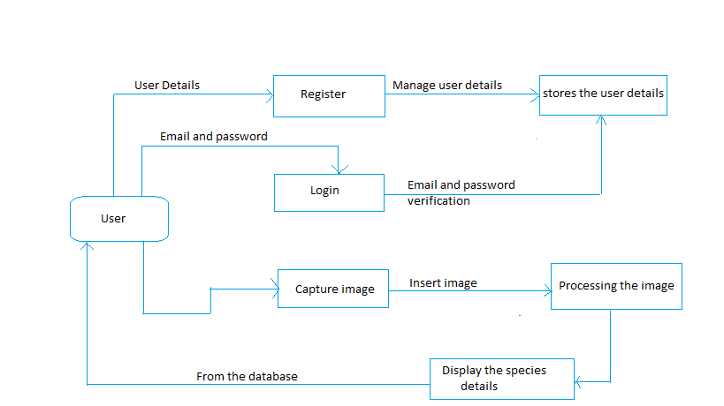

**User Stories**

|  |  |  |  |  |  |  |
| --- | --- | --- | --- | --- | --- | --- |
| **User type**  User  Admin | **Functional**  **Requirement(epic)** | **User story**  **Number** | **User story/ Task** | **Acceptance criteria** | **Priority** | **Release** |
| Registration | USN-1 | As a user, I can register for the application by entering dashboard my email, password, and confirming my password | I can access my account /dashboard | High | Sprint-1 |
| Confirmation | USN-2 | As a user, I will receive confirmation email once I have registered for the application | I can receive confirmationemail & click confirm | High | Sprint-1 |
| Login | USN-3 | As a user, I can log into theapplication by entering Gmail and password. | I can access the dashboard with Gmail account | Low | Sprint-2 |
| Capturing | USN-4 | As a user, I can capture the image of the species. | I can store the photo in the devices. | High | Sprint-1 |
| Upload | USN-5 | As a user, I can upload of the image of the species. | The image fed into the web application | High | Sprint-1 |
| Processing and display | USN-6 | As a Admin, I can display the details of the species. | I can view the details of the species. | High | Sprint-2 |